**Final Report: CRM Application For Public Transport Management System**

|  |  |
| --- | --- |
| 📅 Date | 30JUNE 2025 |
| 👥 Team ID | LTVIP2025TMID31307 |
| 👥 Team Size | 4 |
| 👑 Team Leader | K Veera Venkkateshh |
| 👤 Team Members | - G Satya Veera Durga Prasad  - K Manikanta  - K Vikhitha |
| 📌 Project Name | Public Transport Management System |

**1. INTRODUCTION**

**1.1 Project Overview**

The primary objective of this solution is to enable the Public Transport Department to efficiently:

* Track and manage employee assignments for bus operations.
* Maintain a complete record of buses and their routes.
* Monitor daily trip performance and fare collection.
* Simplify public transport administrative tasks through automation and standardized processes.

The **CRM Application For Public Transport Management System** is a Salesforce-based software application aimed at streamlining and automating core operational processes within a public transport organization. This solution functions as a centralized platform for managing comprehensive public transport data, including employee details, bus station information, bus fleet management, route definitions, ticket fares, and daily trip tracking.

By leveraging Salesforce’s robust platform capabilities, the **CRM Application For Public Transport Management System** ensures that data management is accurate, up-to-date, and easily accessible to stakeholders such as transport administrators, operations managers, drivers, and conductors. The system reduces reliance on manual record-keeping, minimizes errors, and enhances transparency within the public transport management process.

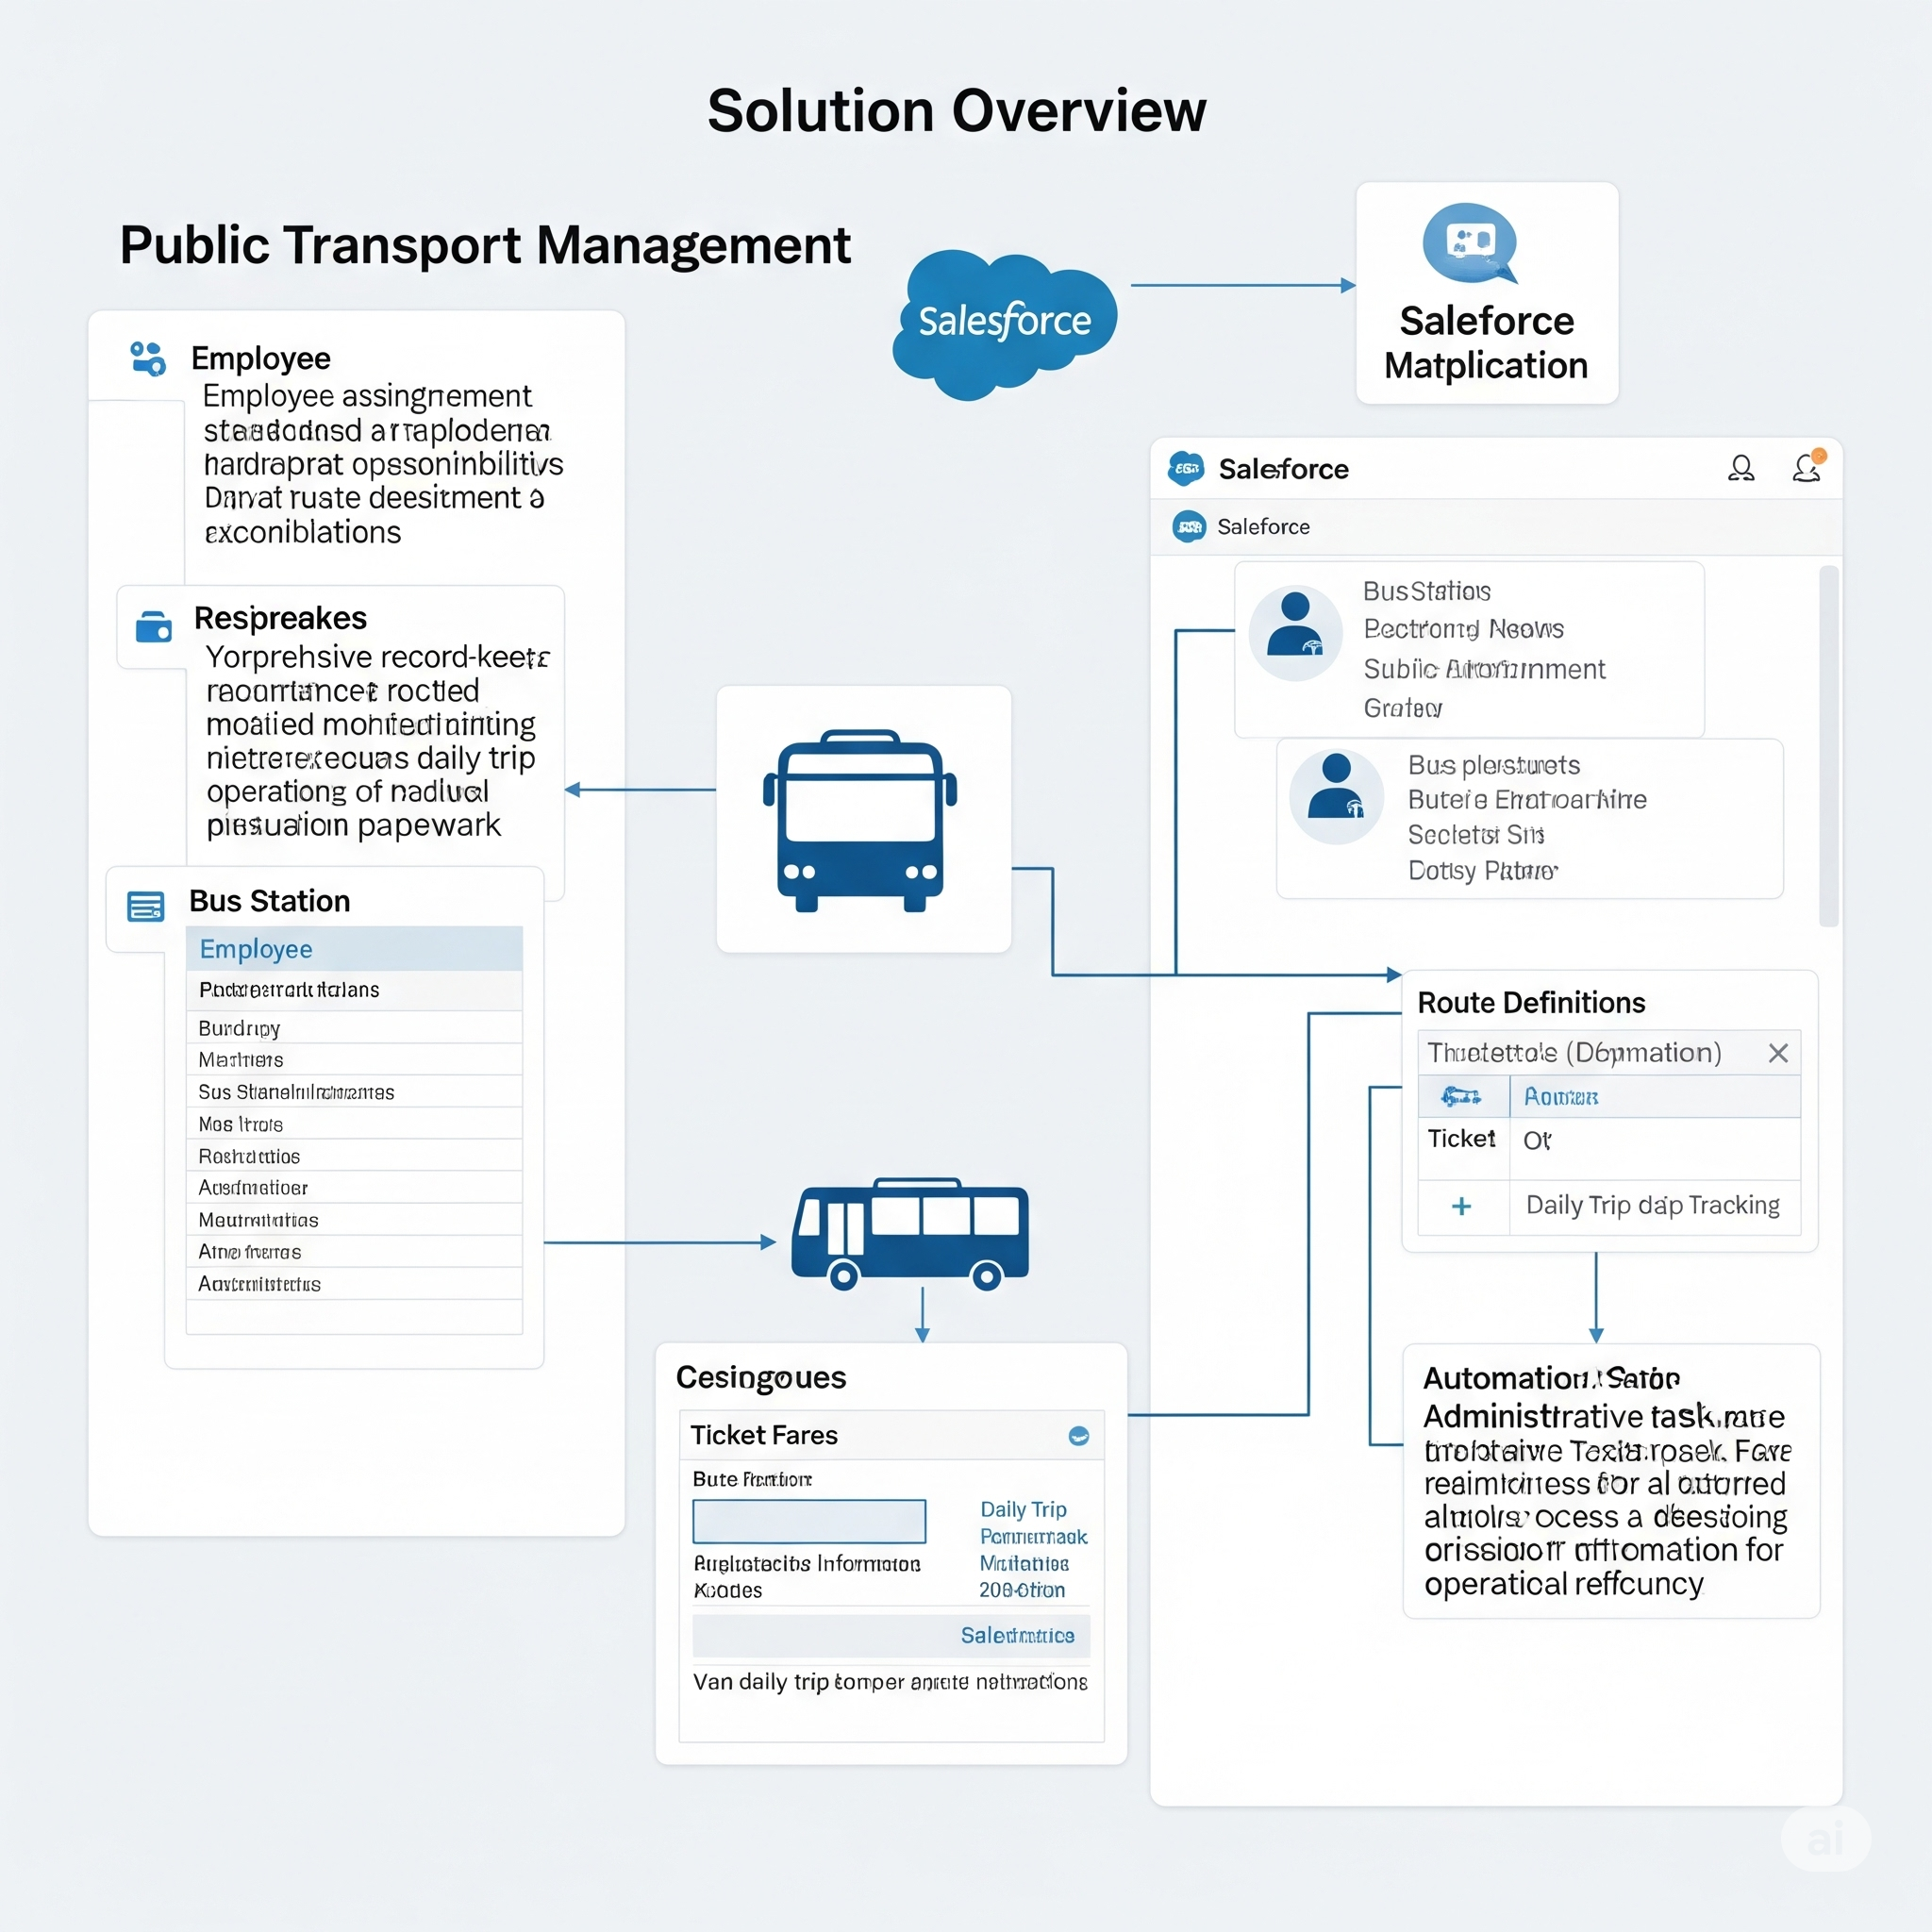

**1.2 Purpose**

The purpose of developing the **CRM Application For Public Transport Management System** is to provide public transport organizations with a scalable, user-friendly system that simplifies operational administration through automation. Specifically, the solution seeks to:

* Eliminate the inefficiencies of manual tracking of public transport operations, including employee assignments to trips, bus scheduling, and fare collection.
* Provide real-time visibility into public transport operational data, enabling managers to make informed decisions regarding resource allocation and trip optimization.
* Enhance accountability by maintaining accurate records of daily trip data, bus assignments, and employee roles.
* Foster a structured and consistent approach to public transport management using Salesforce’s standard and custom features, including automation tools, reports, and dashboards.

In summary, the solution is designed to improve organizational productivity, reduce administrative burden, and support strategic planning for public transport services.

**1.3 Scope**

The initial scope of the **CRM Application For Public Transport Management System** includes:

* **Employee Management:** Creation, modification, and viewing of employee records with roles (e.g., Driver, Conductor, Administrator).
* **Bus & Bus Station Management:** Management of bus fleet details, bus stations, and route definitions.
* **Trip Management:** Scheduling of daily bus trips, assignment of buses and employees to trips, and tracking of trip status.
* **Fare Management:** Definition and management of ticket fares for various routes and passenger types.
* **Reporting & Analytics:** Generation of real-time reports and dashboards for key operational metrics like passenger counts, revenue, and trip efficiency.
* **Automation:** Implementation of Salesforce Flows for automating processes like fare calculation and resource assignment.
* **User Access:** Role-based access for Transport Administrators, Operations Managers, Drivers, and Conductors.

**1.4 Technologies Used**

The **CRM Application For Public Transport Management System** is built entirely on the Salesforce platform, leveraging its robust cloud capabilities. Key technologies include:

* **Salesforce Lightning Experience:** For the user interface.
* **Salesforce Standard & Custom Objects:** For data modeling and storage (e.g., Employee, Bus Station, Bus, Route, Ticket Fare, Daily Bus Trip).
* **Salesforce Flows:** For process automation and business logic.
* **Salesforce Reports & Dashboards:** For analytics and operational insights.
* **Salesforce Profiles, Roles, and Permission Sets:** For robust access control.
* **Salesforce Email Alerts & Chatter Notifications:** For internal communications and reminders.
* **REST APIs:** For potential future integrations with external systems.

**2. IDEATION PHASE**

**2.1 Problem Statement**

Manual processes for public transport administration lead to significant inefficiencies, data inconsistencies, and a critical lack of real-time visibility across employee management, bus operations, trip tracking, and revenue collection. This fragmented approach leads to several challenges:

* Data inconsistencies due to manual updates and human errors.
* Lack of real-time visibility into bus schedules, employee assignments, and actual passenger data.
* Inefficient resource utilization, as managers struggle to assess bus availability and employee workload for specific routes.
* Difficulty in generating reports for operational reviews, revenue analysis, or audits.

The absence of an integrated, automated system hampers decision-making, reduces operational efficiency, and increases administrative overhead for public transport departments. Therefore, there is a clear need for a unified solution that simplifies, centralizes, and automates these processes.

**2.2 Empathy Map Canvas**

Below is a conceptual empathy map for key stakeholders in a Public Transport Management System:

| EMPLOYEE / STAKEHOLDER | SAYS | THINKS | FEELS | DOES |
| --- | --- | --- | --- | --- |
| **Transport Administrator** | "It's hard to manually track all bus trips and assignments." | "I need a system that reduces my manual work and prevents errors." | Frustrated by redundant tasks; wants efficiency. | Manually updates schedules, follows up via phone/email for trip status. |
| **Transport Operations Manager** | "I want to see real-time data on bus utilization and passenger trends." | "It would be helpful to have a dashboard view of all operations." | Concerned about inefficient resource allocation; wants better insights. | Calls dispatchers, requests daily reports, compiles data manually. |
| **Driver/Conductor** | "I'm unsure about my exact trip assignments for today." | "Am I being fairly assigned routes, or is there a better way to see my schedule?" | Anxious about unclear schedules or responsibilities. | Calls supervisor for clarification on routes and assignments. |

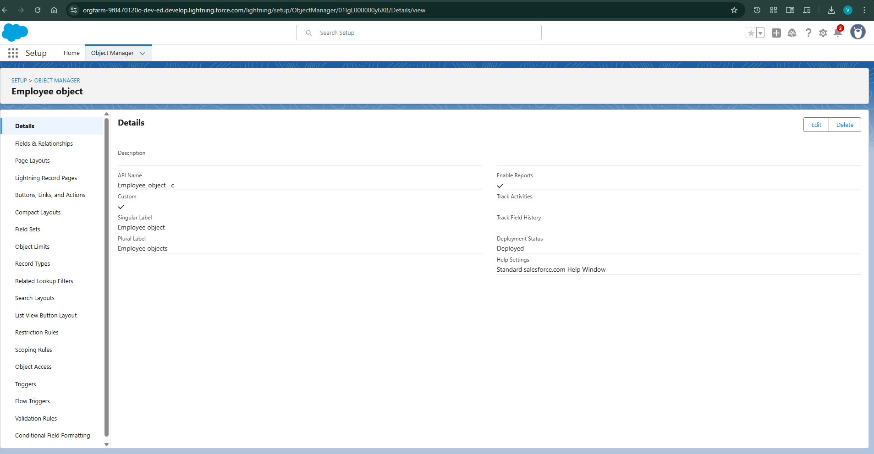

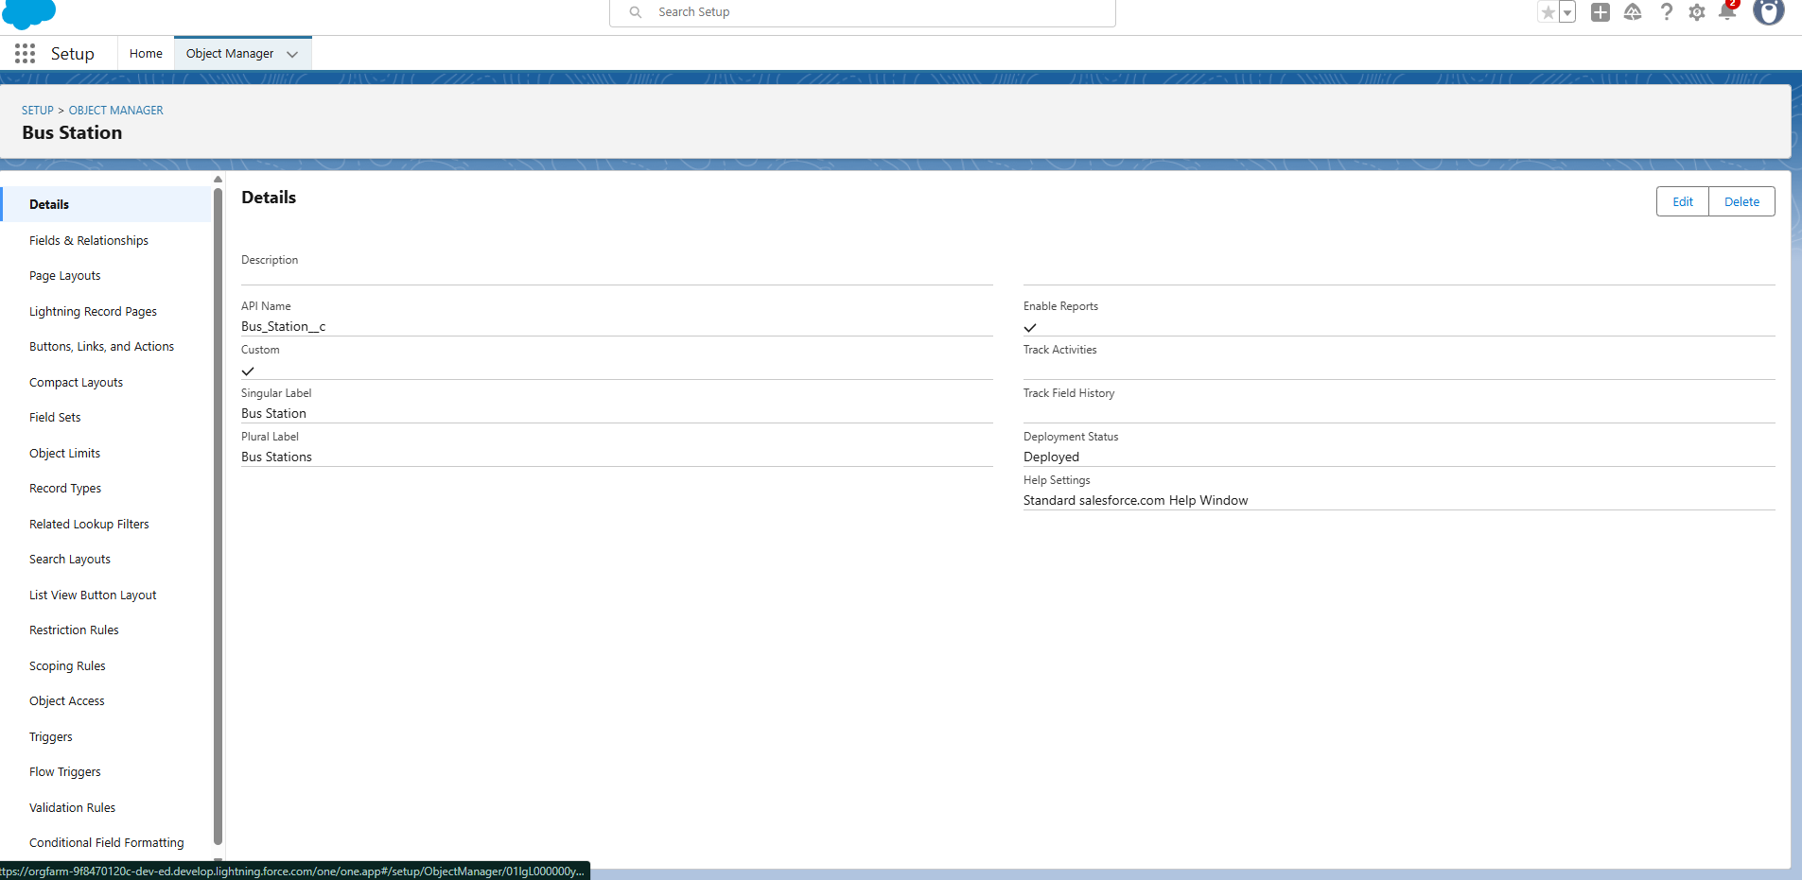

**2.3 Brainstorming**

During the ideation phase, multiple concepts and approaches were considered to address the identified problems in public transport management:

* **Centralized data model:** Use Salesforce custom objects (e.g., Employee, Bus Station, Bus, Route, Ticket Fare, Daily Bus Trip) with proper relationships.
* **Automated trip and resource assignment tracking:** Leverage Salesforce Flows to automate assigning employees and buses to daily trips.
* **Dashboards and reports:** Provide real-time visualizations for managers to monitor trip efficiency, revenue, and resource allocation.
* **Role-based access:** Ensure data privacy and access control, so only authorized personnel (transport administrators, drivers, managers) can view or modify relevant information.
* **Alerts & notifications:** Implement automated reminders for trip schedule changes or exceptional events (e.g., bus breakdowns).
* **Mobile accessibility:** Consider mobile-friendly layouts for employees (drivers/conductors) and managers to access data on the go.

These brainstorming outcomes laid the foundation for designing a robust solution aligned with public transport operational needs.

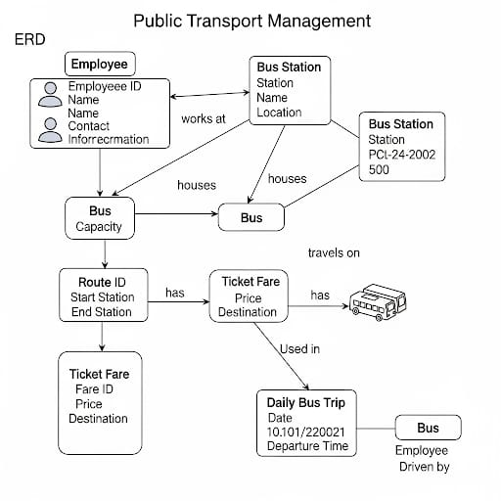

**3. REQUIREMENT ANALYSIS**

**3.1 Customer Journey Map**

Here’s a conceptual outline of the customer (Transport Admin/Manager) journey using the solution:

| Stage | Actions | Pain Points Solved | System Response |
| --- | --- | --- | --- |
| **Login & Access** | Transport Admin logs into the Salesforce platform. | Ensures secure access. | Provides authenticated access based on roles (Administrator, Manager, Driver/Conductor). |
| **Trip Scheduling** | Admin creates daily bus trip schedules in the system. | Eliminates manual scheduling errors and inconsistencies. | Automatically links trips to routes, buses, and assigned employees; triggers notifications for assignments. |
| **Bus Assignment** | Admin assigns specific buses to scheduled trips. | Avoids double-booking or misallocation of buses. | Updates bus status; generates assignment records. |
| **Monitoring & Reporting** | Manager views dashboards for current trip status, passenger counts, and revenue. | No longer needs to compile data manually for operational oversight. | Displays real-time reports, charts, and alerts on key transport metrics. |
| **Review & Audit** | Manager generates reports for performance analysis or audits. | Simplifies audits and compliance checks. | Exports data in required formats (PDF, CSV, Excel) for easy sharing and review. |

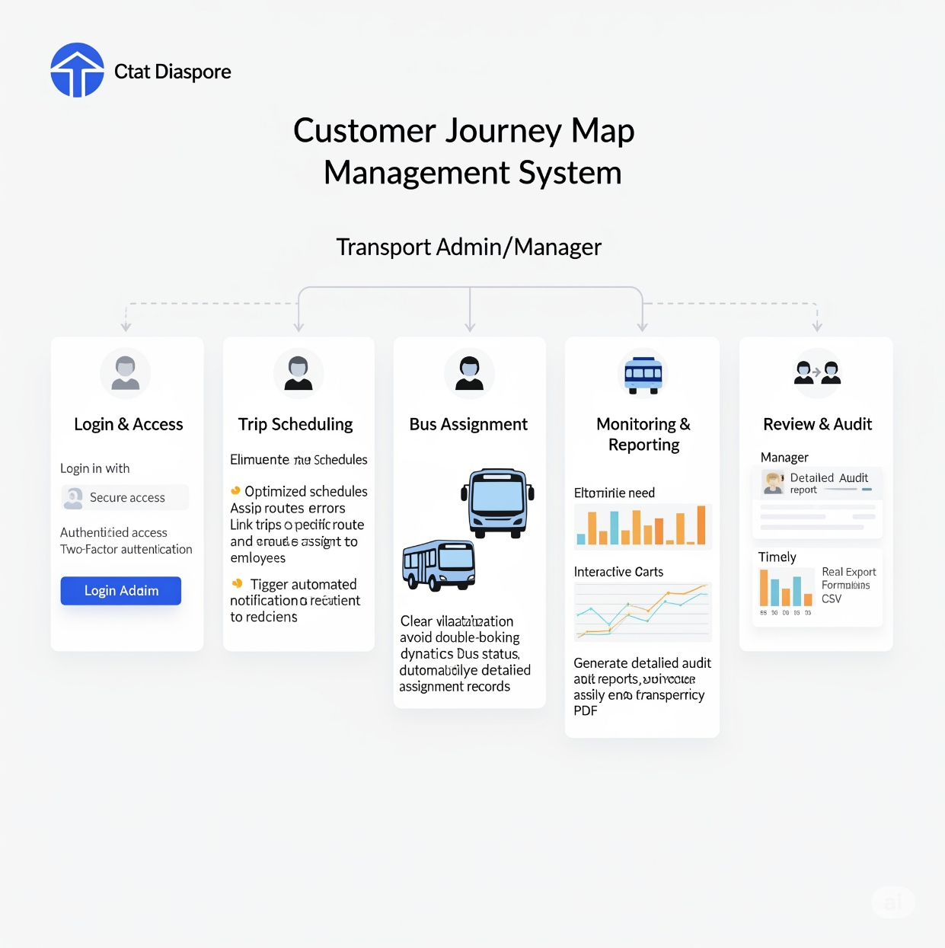

**3.2 Solution Requirement**

**Functional Requirements**

| FR No. | Functional Requirement (Epic) | Sub Requirement (Story / Sub-Task) |
| --- | --- | --- |
| FR-1 | Employee Management | Create, edit, and delete employee records. |
| FR-2 | Employee Management | Define and assign roles and responsibilities to employees. |
| FR-3 | Bus & Station Management | Maintain information on all bus stations (location, facilities). |
| FR-4 | Bus & Station Management | Maintain detailed records of all buses (model, capacity). |
| FR-5 | Trip Management | Manage bus schedules and assign buses to specific routes and trips. |
| FR-6 | Trip Management | Define and manage ticket fares for different routes and bus types. |
| FR-7 | Trip Management | Track daily trips for each bus (start/end times, routes, driver). |
| FR-8 | Trip Management | Record the number of passengers on each trip. |
| FR-9 | Automation | Calculate and track the total ticket fare amount collected from each trip. |
| FR-10 | Reporting & Dashboards | Provide real-time dashboards for key metrics (passenger count, revenue). |
| FR-11 | Reporting & Dashboards | Generate reports on various operational metrics. |

**Non-Functional Requirements**

| NFR No. | Non-Functional Requirement | Description |
| --- | --- | --- |
| NFR-1 | Usability | User-friendly interface for all roles (Transport Admins, Drivers, Conductors, Managers). |
| NFR-2 | Security | Role-based access, data protection for operational data, and compliance with data standards. |
| NFR-3 | Reliability | High availability and accuracy of public transport operational data. |
| NFR-4 | Performance | Fast response times for viewing trip details, accessing reports, and dashboard loading. |
| NFR-5 | Availability | 99.9% uptime on the Salesforce platform. |
| NFR-6 | Scalability | Capable of handling increasing users, buses, daily trips, and passenger data. |

**Automation Requirements**

* Auto-calculate total ticket fare amount per trip based on passenger count and defined fares.
* Send reminders for upcoming trip assignments to drivers/conductors.
* Auto-update dashboards in real-time with new trip data and revenue figures.

**3.3 Data Flow Diagram**

The data flow diagram represents how data moves through the **CRM Application For Public Transport Management System**. Key flows include:

* **Transport Administrator Input:** Enters and maintains records for Employees, Bus Stations, Buses, Routes, Ticket Fares, and Daily Bus Trips.
* **Employee Data:** Entered/maintained in the Employee object.
* **Bus and Trip Data:** Entered/maintained in Bus, Route, and Daily Bus Trip objects.
* **Fare Data:** Entered/maintained in Ticket Fare objects.
* **System (Salesforce):** Processes and stores all operational data, automates calculations (e.g., total fare), and generates assignments (drivers/buses to trips).
* **Transport Operations Manager Access:** Accesses real-time reports and dashboards for insights into passenger counts, revenue, and trip efficiency.
* **Data:** All operational data is stored securely and centrally in the Salesforce database, ensuring consistency and accessibility for reporting and analysis.
* 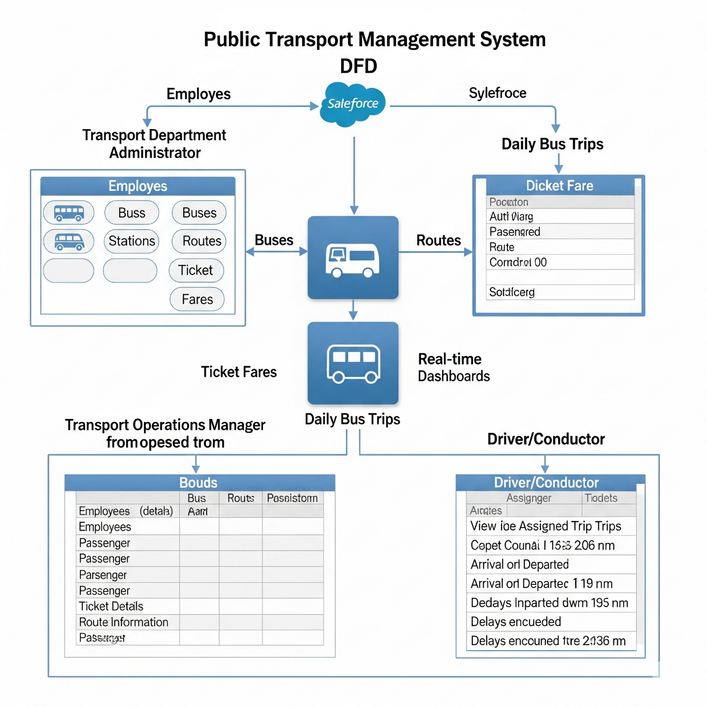

**3.4 Technology Stack**

| Component | Technology / Tool |
| --- | --- |
| Platform | Salesforce (Lightning Experience) |
| Data Objects | Salesforce Standard & Custom Objects (Employee, Bus Station, Bus, Route, Ticket Fare, Daily Bus Trip) |
| Process Automation | Salesforce Flows |
| Reporting | Salesforce Reports, Dashboards |
| Access Control | Salesforce Profiles, Roles, Permission Sets |
| Notifications | Salesforce Email Alerts, Chatter Notifications |
| Optional Integrations | REST APIs (for external ticketing or GPS tools) |

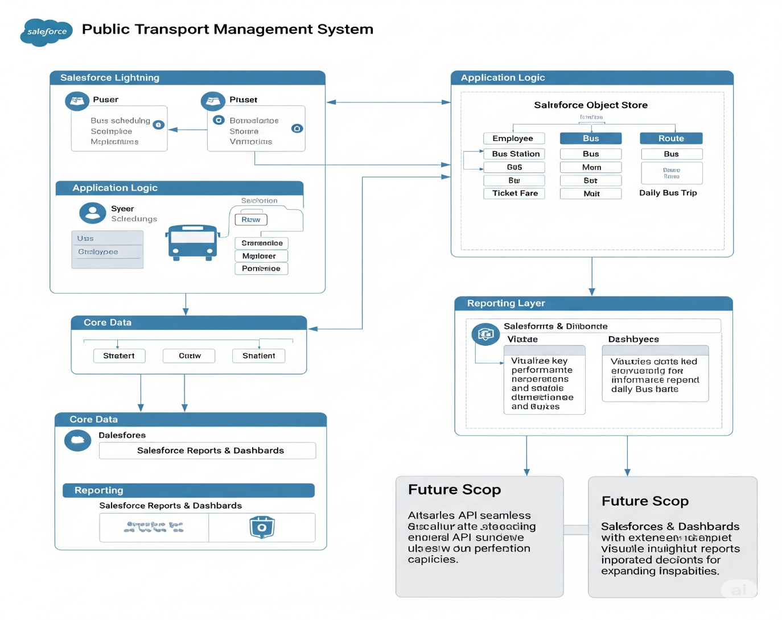

**4. PROJECT DESIGN**

**4.1 Problem Solution Fit**

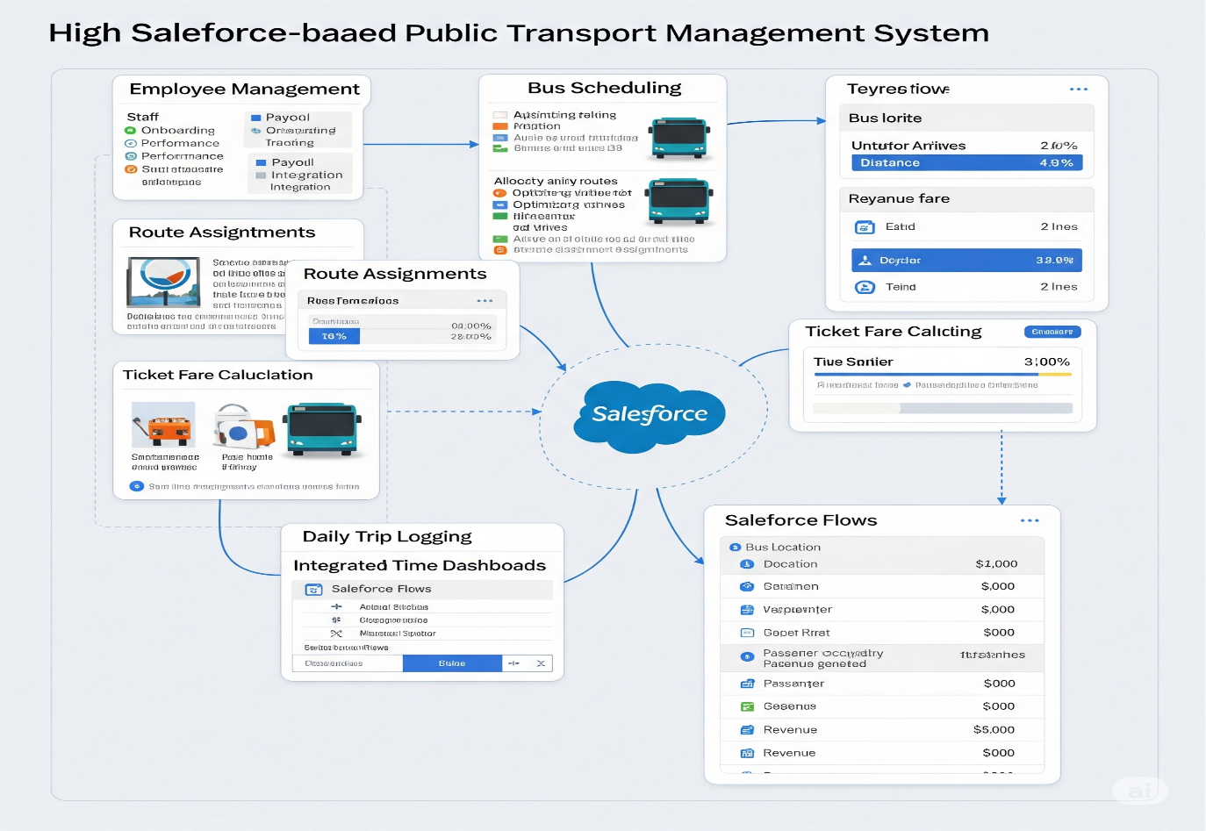

The **CRM Application For Public Transport Management System** directly addresses the inefficiencies found in traditional public transport operational practices:

* **Problem:** Manual processes for managing employee assignments, bus schedules, trip tracking, and fare collection are error-prone, time-consuming, and lack real-time visibility.
* **Solution Fit:** By leveraging Salesforce’s platform, this solution integrates employee, bus, trip, and fare data into a centralized system. It provides automated tracking, dynamic reporting, and streamlined workflows that ensure data accuracy and operational efficiency for public transport. The solution aligns with organizational needs by reducing manual effort, enhancing transparency, and enabling better decision-making through real-time insights.

**4.2 Proposed Solution**

The proposed solution for the **CRM Application For Public Transport Management System** is designed with the following components:

* **Salesforce Custom Data Model:**
  + **Employee Object:** Captures employee details (name, ID, role, contact info, etc.) involved in public transport operations.
  + **Bus Station Object:** Stores information about bus stops/stations (name, location).
  + **Bus Object:** Records bus details (registration number, model, capacity, status).
  + **Route Object:** Defines bus routes (name, start/end points, key stops).
  + **Ticket Fare Object:** Manages fare structures (fare amount, route/bus type applicability).
  + **Daily Bus Trip Object:** Tracks individual bus trips (date, route, assigned bus, driver, conductor, actual start/end times, passenger count).
* **Relationships:**
  + Many-to-many between Employee and Daily Bus Trip (e.g., driver and conductor for one trip).
  + One-to-many between Bus and Daily Bus Trip.
  + One-to-many between Route and Daily Bus Trip.
  + One-to-many between Ticket Fare and Daily Bus Trip.
* **Automation (Salesforce Flows):**
  + Flows to automatically calculate the total ticket fare amount for each trip based on passenger counts and defined fares.
  + Flows to automate the assignment of drivers/conductors and buses to daily trips.
  + Flows to send notifications for key events (e.g., upcoming trip assignments, delays).
* **Reports & Dashboards:**
  + Pre-built reports showing daily passenger counts, revenue per route/bus, trip efficiency, and bus utilization.
  + Interactive dashboards for managers to monitor the overall status of public transport operations.
* **Role-based Access:** Profiles and permission sets ensure that Transport Administrators, Operations Managers, Drivers, and Conductors see only the data relevant to their roles.

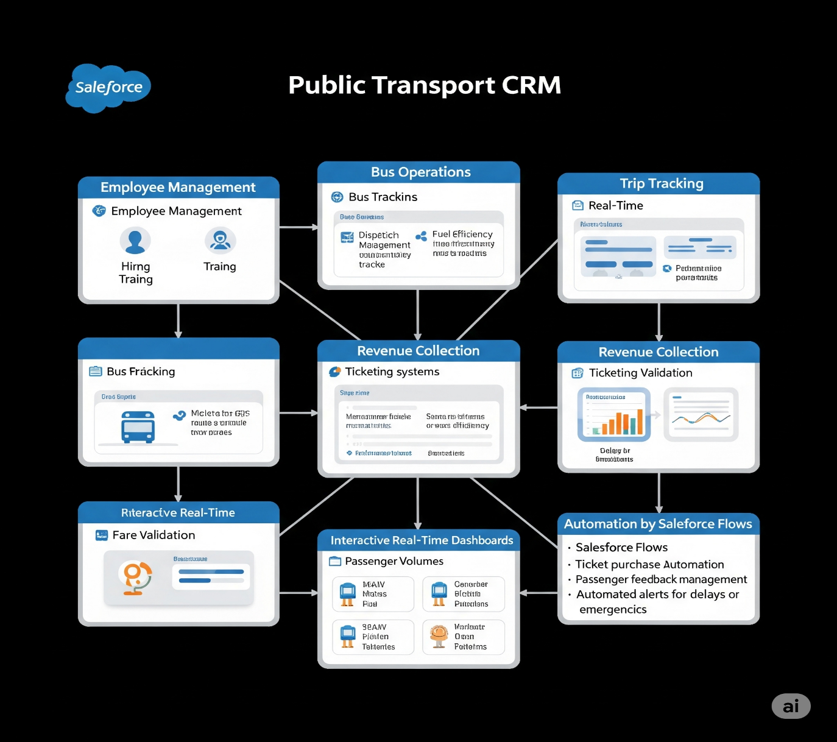

**4.3 Solution Architecture**

Here’s a conceptual breakdown of the architecture for the Public Transport CRM on Salesforce:

* **Data Interaction Flow:** Transport Administrators create and manage employee, bus station, bus, route, ticket fare, and daily bus trip records.
* **Automation & Processing:** Trip scheduling and data entry trigger Salesforce automation flows (e.g., fare calculation, resource assignments) that update related records and dashboards.
* **User Interaction:** Users interact with the system based on their assigned permissions (e.g., drivers view their assigned trips, managers access operational reports).
* **Insights:** Reports and dashboards provide real-time insights into public transport operations, enabling data-driven decision-making.

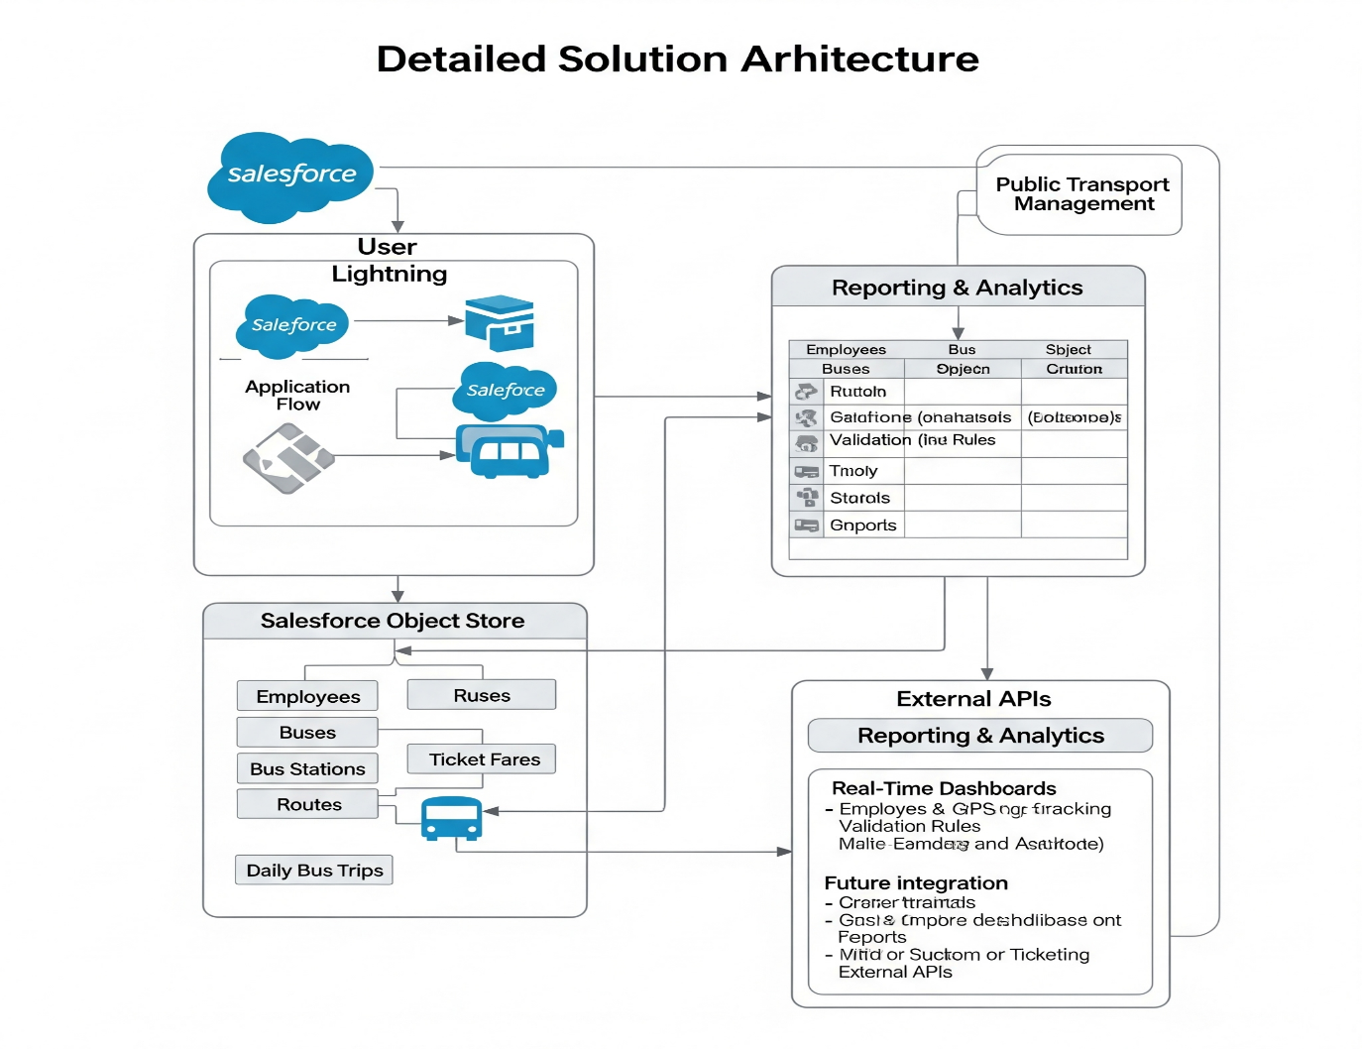

**5. PROJECT PLANNING & SCHEDULING**

**5.1 Project Planning**

The **CRM Application For Public Transport Management System** follows a structured development life cycle to ensure that the solution is designed, implemented, and deployed effectively. The project plan is divided into well-defined phases, each with specific objectives, deliverables, and timelines.

**Planned Phases & Activities**

| Phase | Activities | Duration |
| --- | --- | --- |
| 1. Requirement Gathering | - Identify business needs specific to public transport - Collect detailed requirements from transport administrators, managers, drivers. | 1 week |
| 2. Solution Design | - Design data model (custom objects for bus, trip, fare, etc.) - Plan automation logic (flows for fare calculation, assignments) - Design reports and dashboards. | 1 week |
| 3. Configuration & Development | - Set up Salesforce custom objects and relationships - Build page layouts and record types - Develop automation (Flows) - Configure reports and dashboards. | 2 weeks |
| 4. Testing | - Functional testing (trip scheduling, fare calculation, assignments) - Performance testing (load on dashboards, automation triggers). | 1 week |
| 5. Deployment & Training | - Deploy solution to production - Conduct user training sessions for transport staff - Gather initial feedback for improvements. | 1 week |

**Milestones**

* Requirements sign-off — End of Week 1
* Design approval — End of Week 2
* Development completion — End of Week 4
* Testing sign-off — End of Week 5
* Go-live — End of Week 6

**Product Backlog, Sprint Schedule, and Estimation**

| Sprint | Functional Requirement (Epic) | User Story Number | User Story / Task | Story Points | Priority | Team Members |
| --- | --- | --- | --- | --- | --- | --- |
| Sprint-1 | Core Data Model & Setup | USN-1 | As a Salesforce Admin, I can create all custom objects and their relationships (Milestone 2). | 5 | High | All |
| Sprint-1 | Employee & Bus Station Management | USN-2 | As a Transport Admin, I can create and manage Employee records with their roles (Milestone 5). | 3 | High | All |
| Sprint-1 | Bus & Route Management | USN-3 | As a Transport Admin, I can create and manage Bus records and define Routes (Milestone 5). | 3 | High | All |
| Sprint-2 | Trip & Fare Management | USN-4 | As a Transport Admin, I can create Daily Bus Trip records and assign Buses/Employees (Milestone 5). | 5 | High | All |
| Sprint-2 | Trip & Fare Management | USN-5 | As a Transport Admin, I can define and manage Ticket Fares for different routes/bus types (Milestone 5). | 2 | High | All |
| Sprint-2 | Page Layouts & User Experience | USN-6 | As a Salesforce Admin, I can customize Page Layouts for all objects for better usability (Milestone 6). | 3 | High | All |
| Sprint-3 | Automation - Validation Rules | USN-7 | As a Salesforce Admin, I can implement Validation Rules to ensure data integrity (Milestone 7). | 2 | Medium | All |
| Sprint-3 | Automation - Flows | USN-8 | As a Salesforce Admin, I can create Flows to automate trip-related calculations (e.g., total fare) (Milestone 8). | 4 | High | All |
| Sprint-4 | Reporting & Dashboards | USN-9 | As a Transport Manager, I can view real-time reports on passenger counts and revenue (Milestone 10). | 5 | High | All |
| Sprint-4 | Reporting & Dashboards | USN-10 | As a Transport Manager, I can view interactive Dashboards for key operational metrics (Milestone 11). | 3 | High | All |

**Project Tracker**

| Sprint | Total Story Points | Duration | Sprint Start Date (Planned) | Sprint End Date (Planned) | Story Points Completed | Sprint Release Date (Actual) |
| --- | --- | --- | --- | --- | --- | --- |
| Sprint-1 | 11 | 7 Days | 01 July 2025 | 07 July 2025 | [Fill Actual] | [Fill Actual] |
| Sprint-2 | 10 | 7 Days | 08 July 2025 | 14 July 2025 | [Fill Actual] | [Fill Actual] |
| Sprint-3 | 6 | 7 Days | 15 July 2025 | 21 July 2025 | [Fill Actual] | [Fill Actual] |
| Sprint-4 | 8 | 7 Days | 22 July 2025 | 28 July 2025 | [Fill Actual] | [Fill Actual] |

**6. FUNCTIONAL AND PERFORMANCE TESTING**

**6.1 Performance Testing**

Testing is critical to ensure that the **CRM Application For Public Transport Management System** meets both functional and non-functional requirements. The testing phase is designed to validate that the solution performs reliably under expected workloads and accurately delivers the intended features.

**Functional Testing**

Functional testing verifies that every component of the solution works as expected. The following key areas are covered:

* **Employee Data Management:** Ability to create, edit, and delete employee records for transport staff.
* **Bus & Station Management:** Correct creation and management of bus records and bus station details.
* **Trip Scheduling & Assignment:** Verify that buses and employees can be assigned to daily trips accurately. Ensure that trip records are correctly created and reflected in schedules and reports.
* **Fare Calculation:** Confirm that ticket fares are calculated correctly based on defined rules and passenger counts.
* **Automation:** Check that flows for fare calculation and assignment triggers function correctly. Ensure automated updates reflect accurately in dashboards and reports.
* **Reports and Dashboards:** Verify that dashboards display up-to-date, accurate data on passenger counts, revenue, and trip efficiency. Test report filters and export functionalities (PDF, Excel).

**Performance Testing**

Performance testing ensures that the solution remains responsive and stable during normal and peak usage scenarios:

* **Load Testing:** Simulate multiple transport administrators scheduling trips and managers accessing reports simultaneously. Validate response times for loading data-heavy dashboards showing operational metrics.
* **Automation Response:** Measure time taken by flows to execute after triggers (e.g., fare calculation after passenger count entry).
* **Data Volume Testing:** Test system behavior when managing large datasets (e.g., hundreds of buses, thousands of trips, large employee base).
* **Report Generation Speed:** Validate that reports on extensive trip data or revenue are generated without significant delays.

**Testing Approach**

* **Test Environment:** All tests are conducted in Salesforce Sandbox before production deployment.
* **Test Cases:** Detailed test cases are prepared for each functional area and scenario.
* **Defect Tracking:** Any issues identified are logged, prioritized, and resolved before go-live.
* **Acceptance Criteria:** No critical or high-priority defects allowed for production deployment.

**7. RESULTS**

**7.1 Output Screenshots**

Sample screenshots would include:

* **Daily Bus Trip record page:** Showing details, assigned bus, driver, and passenger counts.
* **Bus assignment interface:** Demonstrating the process of assigning buses to trips.
* **Revenue reports:** With current fare collection and passenger numbers.
* **Automation Flows:** Snapshots of flow diagrams configured for fare calculation or trip assignment triggers.
* **Reports and Dashboards:** Real-time charts showing trip status, revenue, and bus utilization.

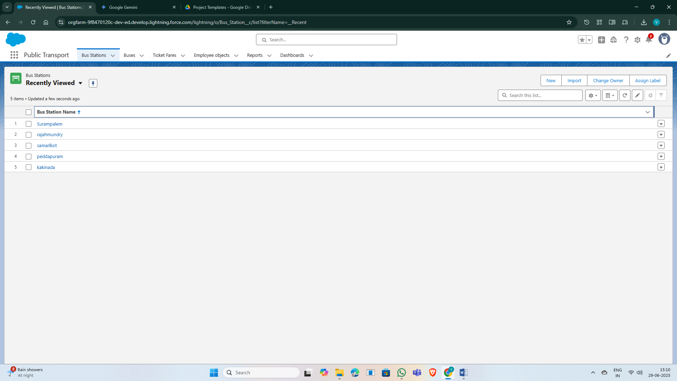

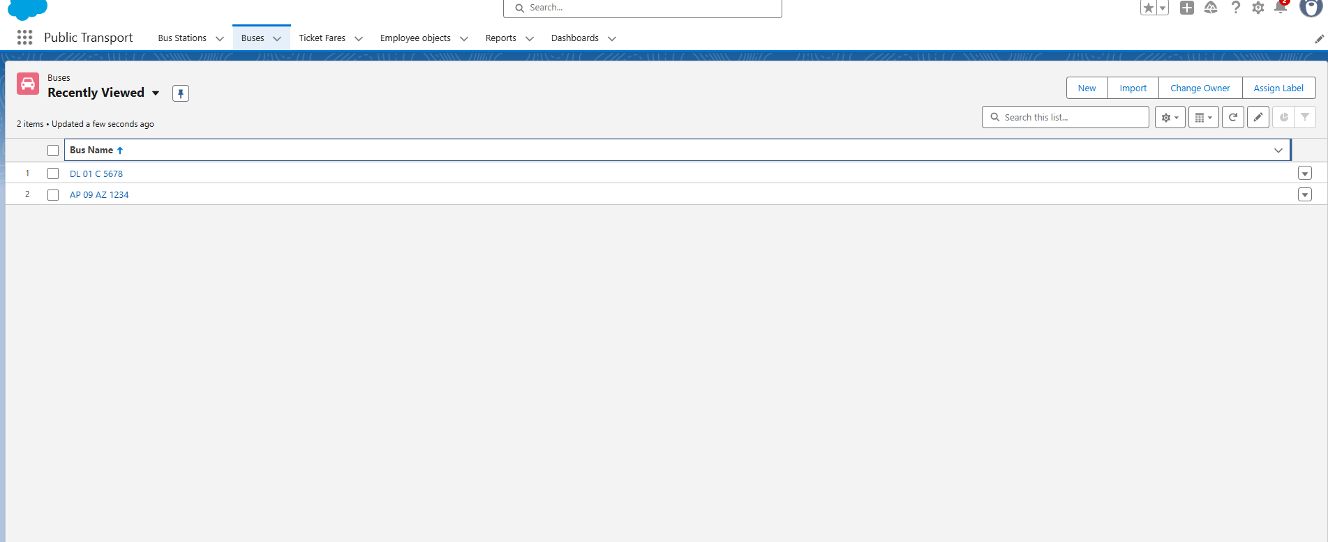

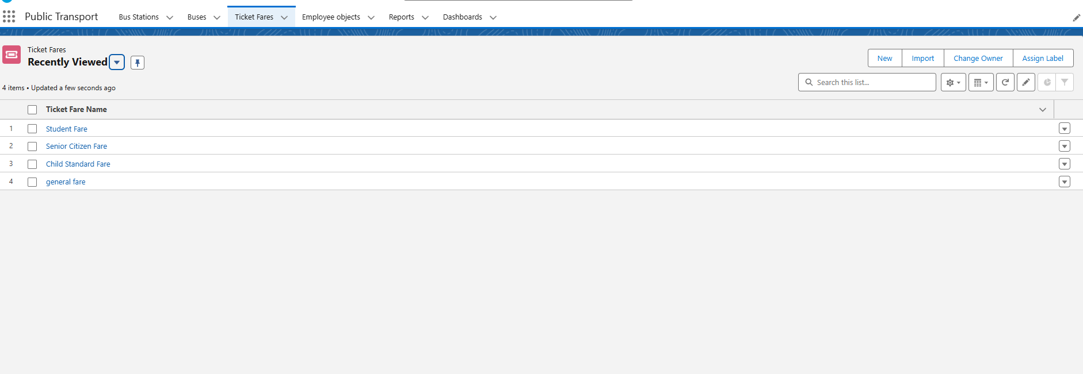

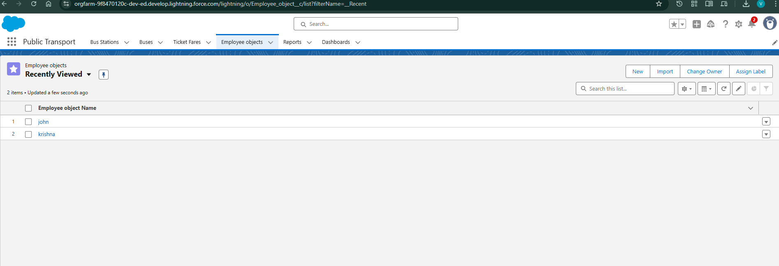

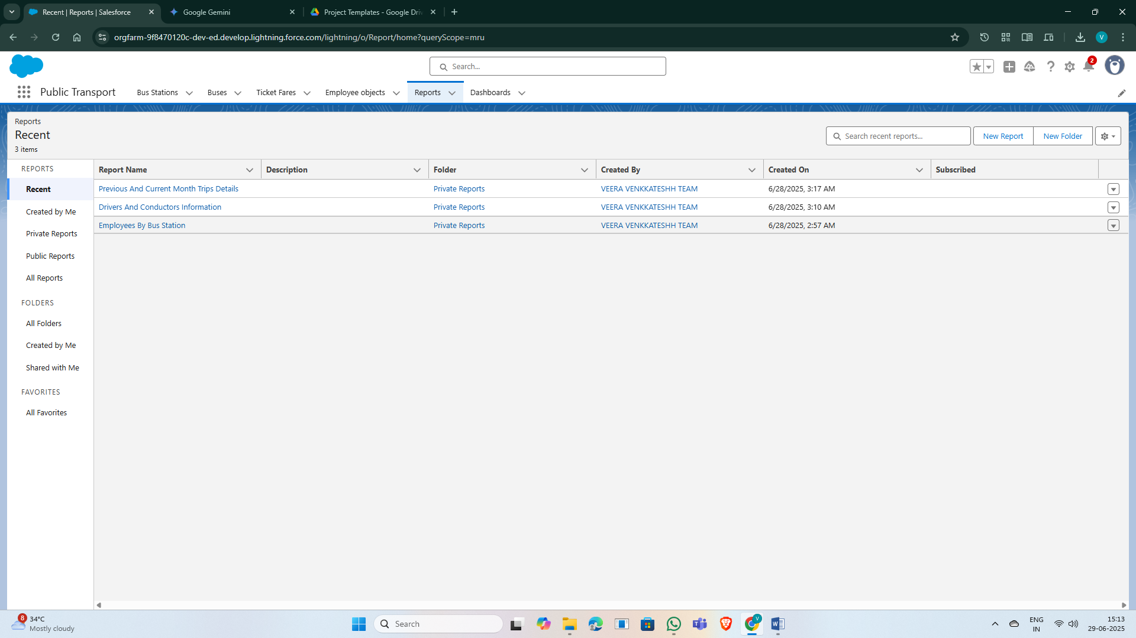

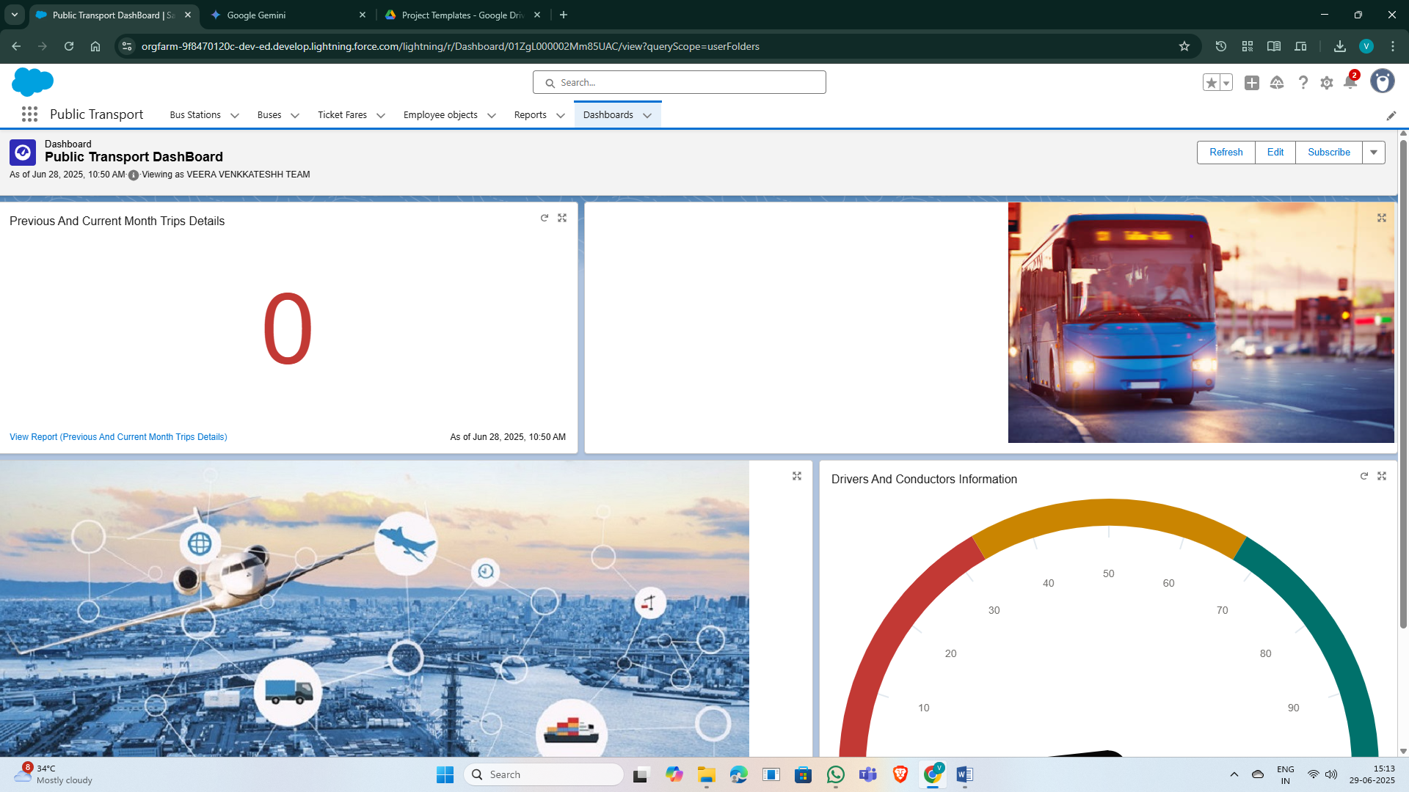

**8. ADVANTAGES & DISADVANTAGES**

**8.1 Advantages**

* **Centralized Data:** All public transport operational data is stored in one place, eliminating data silos and inconsistencies.
* **Increased Efficiency:** Automation of tasks like fare calculation and trip assignment reduces manual effort and human error.
* **Real-time Insights:** Dashboards and reports provide immediate visibility into key metrics, enabling quicker, data-driven decisions.
* **Improved Accountability:** Clear records of employee assignments, bus usage, and trip details enhance oversight and responsibility.
* **Scalability:** Built on Salesforce, the solution can easily scale to accommodate growth in fleet size, routes, and operational complexity.
* **Enhanced User Experience:** Role-based access and intuitive Lightning interface improve usability for transport staff.

**8.2 Disadvantages**

* **Salesforce Licensing Costs:** Implementing on Salesforce involves ongoing licensing fees, which can be a significant investment.
* **Customization Complexity:** Extensive customization might require specialized Salesforce development skills.
* **Initial Data Migration:** Migrating existing operational data from disparate systems to Salesforce can be a complex and time-consuming process.
* **User Adoption:** Successful implementation depends on adequate user training and willingness of transport staff to adapt to the new system.

**9. CONCLUSION**

Throughout the development of the **CRM Application For Public Transport Management System**, key learnings included:

* The importance of a well-defined data model for capturing complex relationships between transport entities (employees, buses, trips, fares).
* Leveraging Salesforce Flows significantly simplifies automation of operational processes like fare calculation and trip assignments.
* The power of real-time reporting and dashboards in providing immediate insights for efficient public transport management.
* Adapting standard CRM functionalities to a specific industry vertical like public transport requires careful analysis of unique operational workflows.
* Agile methodology proved effective in iterating on requirements and incorporating feedback for transport-specific needs.

This project successfully demonstrates the feasibility and benefits of utilizing the Salesforce platform to streamline and automate critical public transport management operations, leading to improved efficiency, data accuracy, and informed decision-making.

**10. FUTURE SCOPE**

The **CRM Application For Public Transport Management System** can be further enhanced in the future with the following additions:

* **Mobile Application for Drivers/Conductors:** Develop a dedicated mobile app for real-time trip updates, passenger boarding/alighting, and incident reporting.
* **Integration with External Ticketing Systems:** Seamlessly connect with electronic ticketing systems for automated fare collection and passenger data synchronization.
* **GPS Tracking Integration:** Integrate with GPS tracking devices on buses to provide real-time bus location, estimated arrival times, and route adherence monitoring.
* **Maintenance Management Module:** Add functionalities to schedule and track bus maintenance, repairs, and service history.
* **Customer Service Portal:** Develop a portal for passengers to view bus schedules, lodge complaints, and provide feedback, improving customer satisfaction directly.
* **Predictive Analytics:** Implement AI/ML models to predict passenger demand, optimize routes, and forecast maintenance needs.

**11. APPENDIX**

**11.1 Source Code (if any)**

**SALESFORCE DEVELOPER LOGIN-** [**https://login.salesforce.com/**](https://login.salesforce.com/)

**SMARTINTERNZ LOGIN-** [**https://apsche.smartinternz.com/**](https://apsche.smartinternz.com/)

Link to GitHub Repository

<https://github.com/VENKKATESHH-KV/A-CRM-Application-For-Public-Transport-Management-System>

**11.2 Dataset Link**

**https://apsche.smartinternz.com/**

**11.3 GitHub & Project Demo Link**

**GitHub link-** [**https://github.com/VENKKATESHH-KV/A-CRM-Application-For-Public-Transport-Management-System**](https://github.com/VENKKATESHH-KV/A-CRM-Application-For-Public-Transport-Management-System)

**Demo Video Link- <https://youtu.be/GgvNLmUJmBw>**